Eastern & Midlands Regional Waste Management Planning
Briefing Note
1.0 Planning Regions
In 2001 Ireland was divided into 10 Regions for Waste Management Planning but Local Authorities clearly recognised the desirability of rationalising regions allowing for greater concentration of resources whilst also considering geographical differences.
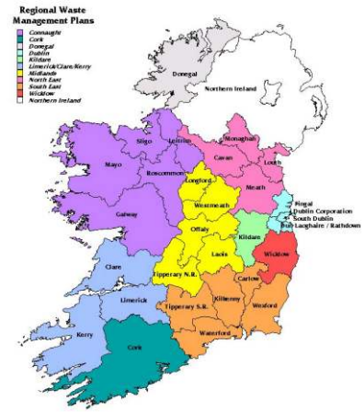

Figure 1.0 Original 10 Waste Management Regions
The Minister in the Policy statement – A Resource Opportunity- Waste Management Policy in Ireland issued in July 2012 indicated that:-

“ local authorities undertaking their waste management planning responsibilities, guided by the programme of reform of local government structures which is currently underway, will significantly reduce the number of regional formations,(currently 10) to no more than 3.”
Fig 1.0: Original 10 Waste Regions

The original 10 Regions were as shown Fig 1.0 above.

In October 2012 the Minister indicated a reconfiguration of the Regions in the Action Programme for Effective Local Government - A Guide to Putting People First. The Waste Management Regions were to be reconfigured in line with the Assembly Regions which are shown in Table 1 below :-

Table 1.0 Details of Newly Configured Waste Management Planning Regions
Waste Management Plan Region | Local Authorities | Population
Eastern & Midlands | Dublin City, Dun Laoghaire -Rathdown, South Dublin, Fingal, Wicklow, Kildare, Laois, Offaly, Westmeath, Longford, Meath & Louth | 2,209,463
Southern | Carlow, Kilkenny, Wexford, Waterford, Tipperary, Cork City & County, Kerry, Clare & Limerick | 1,541,439
Connacht & Ulster | 9 Donegal, Leitrim, Sligo, Cavan, Monaghan, Galway City & County, Mayo & Roscommon | 837,350

In early 2013 the County & City Managers Association (CCMA) agreed the reconfiguration of the Regions as outlined in “Putting People First” and the geographical breakdown of the Waste Regions is shown in Fig 1.1 below:-

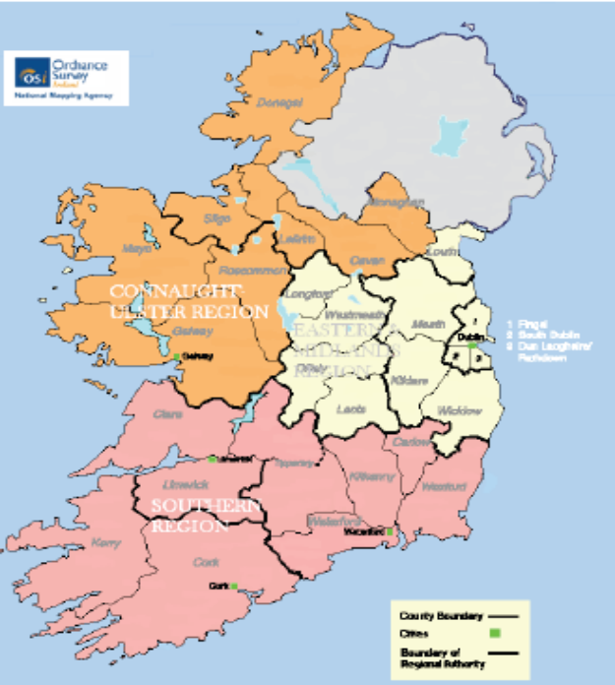
Fig 1.1 New Waste Management Planning Regions

Table 1.2 Lead Authorities for New Waste Regions
Waste Management Plan Region | Local Authorities
Eastern & Midlands | Dublin City Council
Southern | Limerick & Tipperary Authorities
Connacht & Ulster | Mayo County Council

The Plan process in Eastern & Midlands Waste Region will be co-ordinated by Dublin City Council. This was agreed in April by all the Local Authorities in the Region. The process will be strategically managed by a Steering Committee of Senior Management representing all local authorities in the Region.

2.0 Waste Management Planning Process.
The Minister transposed the EU Waste Framework Directive into Irish Law with the publication of the European Communities (Waste Directive) Regulations, 2011 in March 2011. These regulations requested that Waste Management Plans in existence had to be evaluated by the 31st December 2012. In the Eastern & Midlands Region, all the evaluations recommended preparation of New Plans once the arrangement for the New Regions was agreed.
The preparation of the New Waste Management Plans requires that the Local Authorities, under the Waste Management Act 1996, publish a Notice of Intention to commence preparation of the New Plan. Written submissions will be accepted from members of the public and all stakeholders for two months following the publication of the notice. This notice is due to be published in National Newspapers ( Irish Times, Irish Independent & Irish Examiner) on 10th October 2013 ( Copy of Ad text - Appendix 1).
Preparation of the Draft Waste Management Plan for the Eastern & Midlands Waste Region will commence in first quarter of 2014 and it is hoped to publish a draft Plan in mid 2014. There will be a second two month phase of public consultation following the publication of the Draft Plan.
In association with the preparation of the New Waste Management Plans, a Strategic Environmental Assessment (SEA) and an Appropriate Assessment (AA) will also be required. These Assessments will also have a public notification phase which will begin in early 2014.
It should be noted that until such time as the New Plans have been made the existing Waste Management Plans continue in force.
Updated information and all relevant documentation will be available on your Local Authority website during the process.
The Lead Authority (Dublin City Council) can be contacted at 01 2222023 or email engineering@dublincity.ie .

Appendix 1


